**Revise: 06/05/2010 3:20:44 PM**

# Check list before application released

1. Set the ID for Domino's App: 1
2. Application current version: 1.0.0
3. Set application's phone type: see the list

iPhone = 1,

BlackBerry = 2,

Android = 3,

WindowsMobile = 4,

Palm = 5,

Java = 6,

1. Image name & version for the application

These images you can preload by image files or get from server when app is running, used as application's skin. All version of images will set to 0 when first released.

|  |  |  |
| --- | --- | --- |
| **Image Name** | **Description** | **Image** |
| AppIcon | Icon for show on the application |  |
| Background | For main (landing) page and othe pages use background |  |
| InfoIcon_up | Top icon for goto about page |  |
| InfoIcon_down |  |  |
| FindIcon_up | Top icon for goto search page |  |
| FindIcon_down |  |  |
| CloseIcon | Close Icon for mapinfo (when click a store on map) |  |
| BigLogo | For main page |  |
| BlueSquare | For first page |  |
| SmallLogo | For top and map |  |
| Button_Left | 3 pieces |  |
| Button_Center |  |  |
| Button_Right |  |  |
| Button_PressBall | When button pressed, show the ball inside button (left side) |  |
| BottomBar | Bottom bar |  |
| TopBar | Top bar |  |
| FlyerIcon | For store list |  |
| CouponIcon | For store list |  |

1. Message List

|  |  |
| --- | --- |
| **Message name** | **Message** |
| mGPSNotAvailable | We are sorry, but your location could not obtained at this time. Please try searching by postal code/location. |
| mGPSNoPermission | You have not accepted the terms of use for the Google Location Service, or the Google Service is off. |
| mGPSServiceOff | No Location source available. Both Google and GPS are off. |
| mAddrNotResolved | No locations found for the postal code/address that you entered |
| mNoStore | Sorry, there are no locations close to the postal code/address that you entered. |
| mNoCoupon | There are currently no coupons available. |
| mNoFlyer | There are currently no flyers available |
|  |  |
| mAbout |  |
|  |  |
|  |  |
|  |  |

The blue for Domino's: #0064a1

# Pages (Scenes)

## General (For all pages)

Top Bar



**Interactive Elements**

* Global persistent menu at top to allow the user to easily navigate between sections. Version 1.0 of our app will only have 2 buttons, a home button and an info button. The menu will be expanded in future versions to accommodate other buttons such as: “Product Search”, “Coupons”, “Menus”, “Settings" etc...



* + **Home button (Search Button)** – Allows the user quick access to the landing page "**Main Page**".



* + **Info button** – Clicking on this button will bring the user to a page which shows general information page "**About**" – ie. Company Name, website address, corporate phone number, app version number.



The title will changed depends on the page

Bottom Bar



Note: If the phone has button for return to last page then this bar is not needed (Palm, Android, maybe some BB model)

**Interactive Elements**

* Back Button -- Clicking on this button will bring user to last page

For the alert or information message, the style is looks like this.

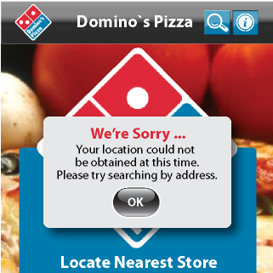

Or use the native popup message function.

## Main Page (Landing Page)

Title: **Domino's Pizza**

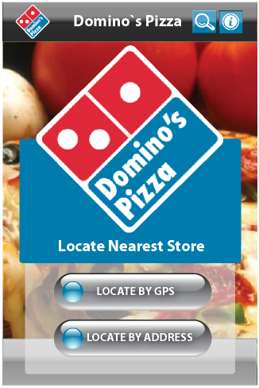

**Interactive Elements**

1. **Locate by GPS** – Clicking on this button will locate all stores closest to your current location, as determined by the GPS
   1. If app cannot get the GPS location at that time, in the same page popup message (**mGPSNotAvailable**) "**We are sorry, but your location could not obtained at this time. Please try searching by postal code/location** ".
   2. If current GPS location available, call webservice, if no stores found popup message message (**mNoStore**) " Sorry, there are no locations close to the postal code/address that you entered. "**,** otherwise display page "**ListView".**
2. **Locate by Postal Code/Location** – Clicking on this button to a page where you can manually enter a postal code, address or city "**FindStore**".

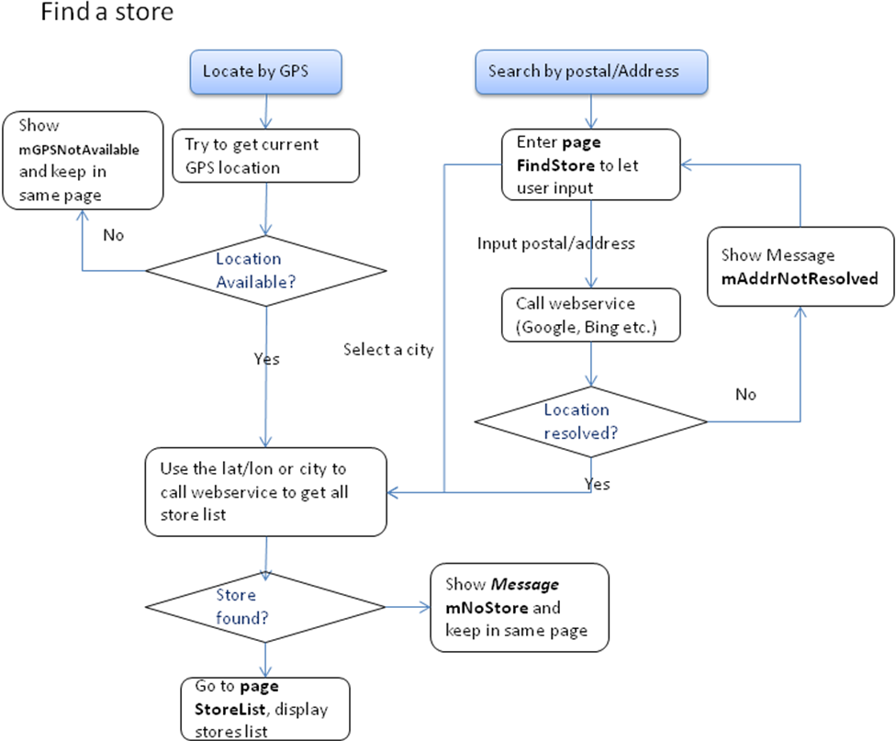

Figure 1 Work flow for "Find a store"

## Page FindStore (Find a store)

title: **Locate by Address**

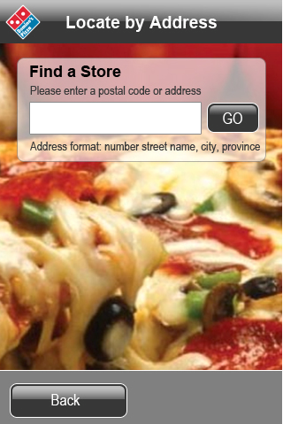

**Interactive Elements**

**Postal code/address search field** – Users can search a store by postal code, or by address. Address is inputted in the following format: *number street name, city, province*. Search results work much the same as locating by GPS.

When the user input postal/address, the app first call a service (now suggest use Google) to convert the address/postal to latitude/longitude, If cannot get the latitude/longitude, popup message (**mAddrNotResolved**) "No locations found for the postal code/address that you entered.".

If success get convert the address to a pair of latitude/longitude, then call webservice to get the store list (same as locate by GPS).

After call our webservice, if no stores found, popup message (**mNoStore**) " Sorry, there are no locations close to the postal code/address that you entered. "

Before get the store list result from our server, keep page in the search page and show an indicator like spin or progress, let the user know it is running. And keep the page not changed after the messages display.

## Page Store List (StoreList)

Title: **Results - List View**

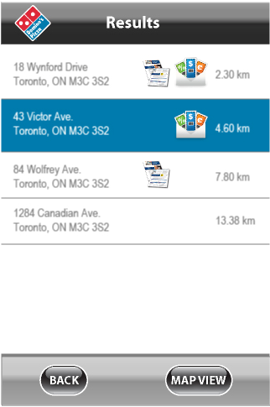

Note: all the start point for the "Direction" and distance is based on the GPS or the address input.

All the stores in the list sorted by distance based on the current location.

All the results will be displayed on one page(*), and use scroll key down/up view. And the button should float on the same position (Bottom).

Format for Each item display

Location:

*1. Number & Street*

*2. City & Province & Postal*

123 Major Mackenzie Dr E

Markham, ON M2S 3C2

Distance:

Unit: km, use 2 decimal digits

~ 2.52 km

If the coupon count is not 0, show the icon



if the flyers count is not 0, show the icon



**Interactive Elements**

1. **Back Button** – Back button will allow the user to go back to the previous page.
2. **Individual Store Listing** – Selecting this will bring you to a page with the store listing’s information, such as address, phone number etc... Page "**StoreView**".
3. **Map View** – Clicking this will bring the user to a map which shows all results in a map Page "**MapView**"

## Page Store Detail (StoreView)

Title**: Store Information**

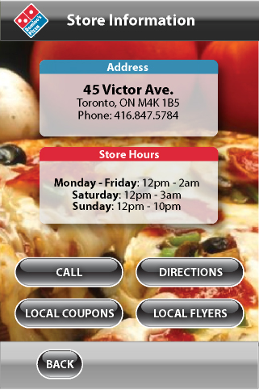

3 parts in this page:

1. Address & Phone: address; city/province/postal; phone
2. Store hours: Work hours
3. Operations: Buttons

**Interactive Elements**

1. **Local Coupons** – Get the coupons from webservice, if no coupon assigned to this store, popup message (**mNoCoupon**) "There are currently no coupons available.", if has coupon, enter the coupon page to show a list of coupons of this store(P**age "CouponList"**)
2. **Local Flyer** – Get the flyer list from webservice, if no flyers assigned to this store, popup message (**mNoFlyer**) "There are currently no flyers available", if has flyers, enter the flyer page to show a list of flyers of this store(P**age "FlyerList"**)
3. **Directions** – Pressing this button will popup a window (page 2.3) to ask user the start point. if select to use current location, then try to get current GPS location, Pressing this will bring the user to a page with turn by turn directions. The directions will be from the nearest location that was determined by the GPS to the chosen location of the store (Page "**Direction**").
4. **Call** – Clicking on this button will start the device’s phone application, and automatically call the store’s number (if the number applied).
5. **Back Button** – Back button will allow the user to go back to the previous page.

## Page MapView

Title: **Results - Map View**

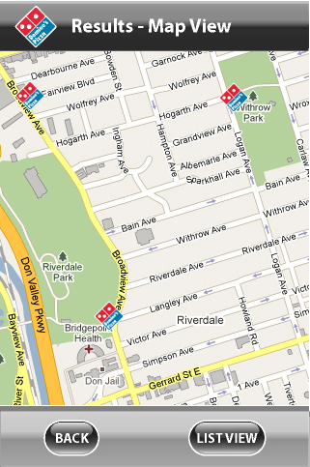

When Map View is selected from the results, the application will display all results on a map as pins, and use the logo as the pin

**Interactive Elements**

**Pins on the Map** – Pressing once on the pin will bring up a caption with abbreviated store information. like this:

43 Victor Ave.

Toronto, ON M3C 3S2

[View More](Branded%20App%20(Detail)-3.docx)

**View More Link** - will bring the user to the store’s information **.**

**Close Button** – Clicking the caption’s close button will close the caption. **(if no this button, when use click any place outside the pop window, it closed)**

**List View** – Brings the user back to the results in list view Page "**StoreList**"

## Page CouponList

title: **Coupons**

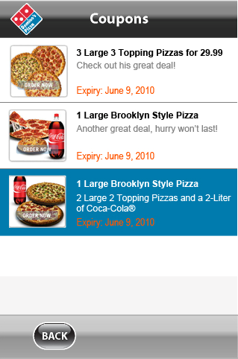

For each item, separated to 2 parts:

1. image (60x60): small coupon (if it is image), or use default coupon icon.

2. Coupon title (up), brief information (middle, if more than 2 lines, replace by ...) and expiry date (bottom, Month and date, no year)

**Interactive Elements**

View: when user click the item, the detail page will be displayed. Page "**CouponDetail**"

## Page Local Coupon (CouponDetail)

**title: Coupon's title**

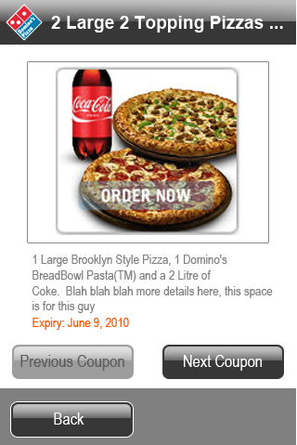

* Top: 320 x 240(you can changed depends on phone's screen size), Image of the coupon (so far, we just support image coupon), it can be scrolled vertical and horizon, also it can be zoomed
* Middle: Description & expiry date
* Bottom: an image list of all available coupons (each 60x60), and show current coupon a little bigger (80 x 80).
* Bottom: if image list is impossible, use 2 buttons for move next or move previous.

**Interactive Elements**

forward, backward (icon): when user click, will loop display coupon's detail forward or backward

back: return to list page (only for iPhone).

if image list, show the coupon which is clicked.

## Page Local Flyer (FlyerList)

Title: **Flyers**

Similar as Coupons List

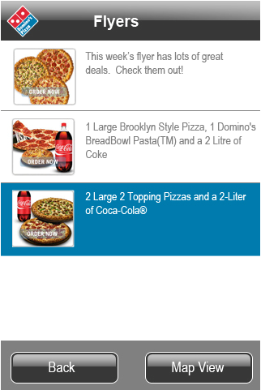

**Interactive Elements**

View: when user click the item, the detail page will be showed, default use the first page of flyer. Page "**FlyerView**"

## PageLocal Flyer (FlyerView)

title: Name of flyer

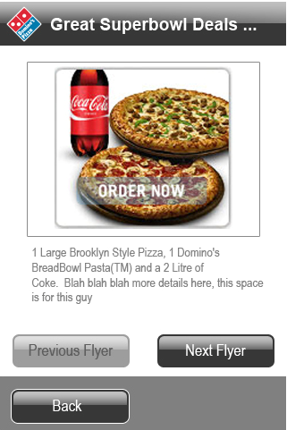

* Top: 320 x 320 (you can changed depends on phone's screen size), Image of the, it can be scrolled vertical and horizon, also it can be zoomed
* Bottom: an image list of all available coupons (each 60x60), and show current coupon a little bigger (80 x 80).
* Bottom: if image list is impossible, use 2 buttons for move next or move previous.

**Interactive Elements**

forward, backward (icon): when user click, will loop display flyer's pagel forward or backward

back: return to list page

quick page: when user select a page, directly display that page

## Page Company Information (About)

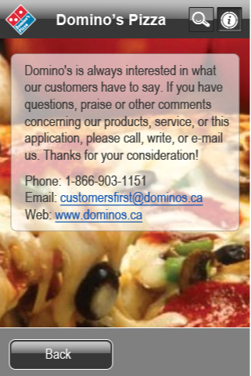

**Display information of Domino's**

**Domino’s always interested in what our customers have to say . If you have questions,praise of othere comments conceming our products,service,or this application,please call,write,or e-mail us.Thanks fo your consideration!**

**Phone: 1-866-903-1151**

**Email:customersfirst@dominos.ca**

**Web:www.dominos.ca**

## Page Direction

When directions button clicked, popup a window to show 3 options

**Interactive Elements**

Use current location/Postal or address

* Use current location, try to get current GPS location, if available, goto direction page/function (Google/Bing, etc)
* Postal or address, if user use address/postal to search store, the input textbox will be filled by previous input. When user click Go/Submit, like find store, first call Google/Bing webservice to resolve the address to lat/lon, and then call native/external function/app to show user the direction page.

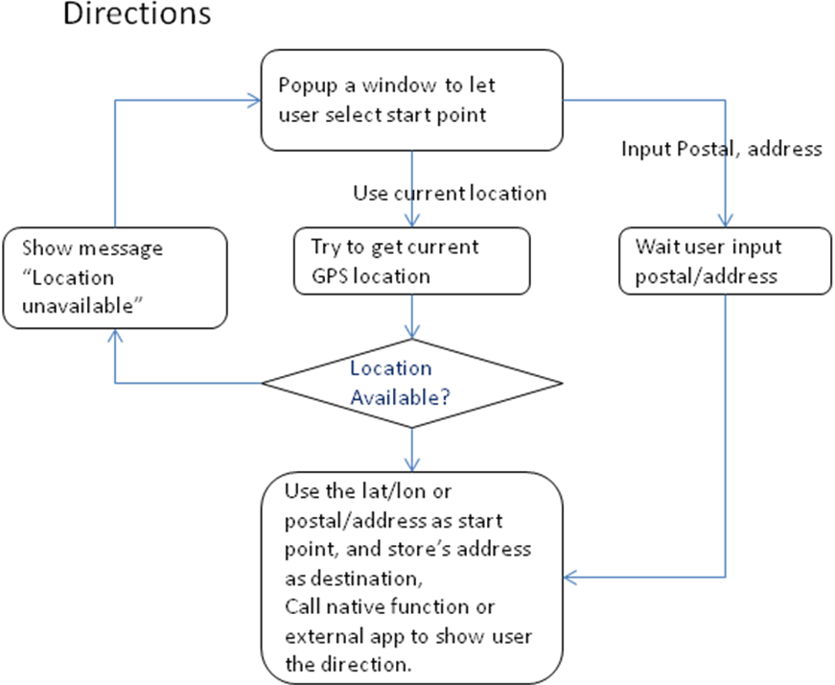

follow example use Google

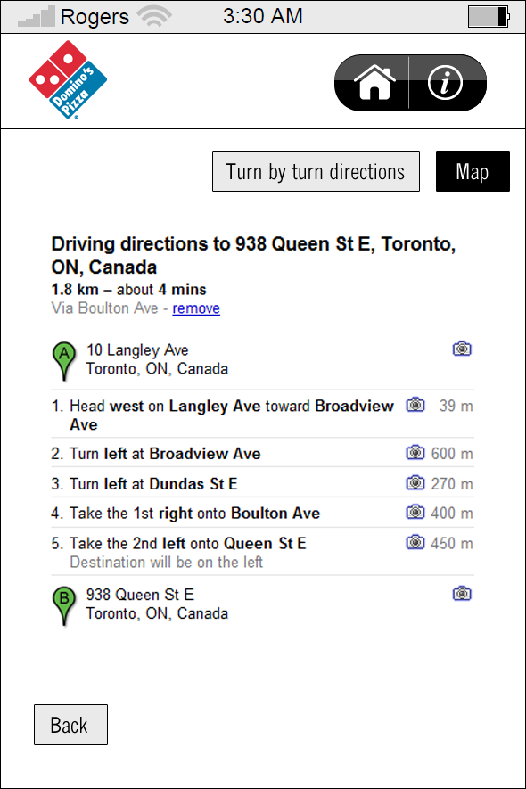

**Interactive Elements**

**Turn by Turn Directions Button** – this will initially be in the “down” position. Allows the user to toggle between “turn by turn” directions, and directions shown on a map.

**Map Button** - Allows the user to see the directions visually. The directions will be shown on a map, and the directions will be denoted by a highlighted path.

**1.1.3**

